**Final Project:**

**Lego Race Car DOE**

**PROJECT REPORT**

**TEAM REPORT SUBMITTED BY**

**TEAM 9, COHORT A.**

|  |  |
| --- | --- |
| **Aman Kumar** | **Akuma185@asu.edu** |
| **Eshwar Chandra** | **Echandr1@asu.edu** |
| **Xueli Zhang** | **Xzhan480@asu.edu** |
| **Sejal Kulkarni** | **Sskulk18@asu.edu** |

**Fall 2018**

**SCM 517 Class Project**

SUMMARY

Designing a Race Car made from Lego blocks is a simulation of Data Driven Quality Management Techniques to analyze which factors contribute for a car to go the longest distance. After running the experiment a couple of times using Minitab 2.0 considering Length, Weight and Wheel size as determinants we concluded based on ANOVA, Measurement System Analysis and Model Adequacy tests that our Race car could go the longer mile by fine tuning major contributing factors using a Ramp made out of cardboard as a testing platform to perform the experiment and averaging the results obtained from it. We used a 2^3 Factorial design after performing several screening experiments to figure out which is the highest contributing factor keeping in mind the cost of building the car. After deciding on Factors, Ramp type and running the DOE to find correlations, we did cost analysis on our models to determine the best fit and concluded that indeed Wheel Size is what mattered the most to distance, but other factors like length and weight are also considerably strong factors in building a good Lego Race Car.

**PROJECT OBJECTIVE AND GOALS**

The project objectives are to design a Race Car made of Lego blocks, measure the horizontal distance that Race Car travelled from the end of the ramp, find the factors that affect the distance and do DOE, analyze the result, make conclusions and recommendations.

The goal of this project is to maximize the distance the car will travel down a pre-constructed ramp and win the “Desert Classic Phoenix Grand Prix”.

**Experimental Setup**:

Materials Used: Ruler, Cardboard Box, Thread, Lego Bricks

**Procedure**:

1. Built a Ramp made out of Cardboard with not much consideration into the angle and height as the angle changes so does the distance.
2. Built a base car out of Legos iteratively considering costs of building and factors like length, height, wheel base.
3. Ran the car down the ramp considering Base Weight Specifications. Noted the distance.
4. Changed the Weight on the car by using Bigger Wheels. Ran it and noted the distance.
5. Changed the Base Weight and ran it again.
6. Changed the length of the car but kept weight same. Ran the car and noted the distance.
7. Changed the Wheel Size to Small and Noted the changes.
8. Also calculated total weights and costs of each model while doing the experiment.
9. Considering our best 3 factors we ran a DOE experiment by having varying High and Low factors.
10. On observing the values from the DOE results, we performed ANOVA analysis and noted the changes.
11. We did measurement system analysis, performed model adequacy checks and formed Normal and Pareto charts to see which factor is contributing the most.
12. We also saw how residual plots for our response factor i.e., distance is a deterministic factor.
13. Main effects and interaction plots were also drawn for correlation.
14. We finally did a Financial analysis and chose the best model based on contributing factors, distance and cost of building the car.

**FACTORS CHOSEN AND THOUGHT PROCESS**

We chose three factors to be measured for distance in running the LEGO car model, which are length, weight and wheel base. Our thought process went this way. We had to consider Weight as the most contributing factor for distance. While Height is also a factor it is directly correlated with Weight since we are using Lego Bricks and build on top of a common base. Length is a factor because it affects the weight distribution on the tires. Weight changes the traction and as the weight increases the distance travelled decreases. We also decided that Spoilers does not really affect anything to be considered as a factor.

**HOW WE MEASURED THE RESPONSE VARIABLE**

We used a cardboard box to build our ramp, and then we ran the car from the top of ramp and measured the horizontal distance from the edge of the ramp to the point that car stopped. We measured it using thread starting from the end of the ramp to the back wheel of the car for better accuracy and calculated the distance using a ruler and noted it in Excel. And for each run for each base model and change, we ran it 5 times and then averaged them for accuracy. We then did a 2^3 factorial design in minitab with 2 replicates and recorded the average distance in separate rows as the observed values.

**CHOOSING EXPERIMENTAL DESIGN AND BLOCKING NOISE**

We did a Full factorial design because individual factors were complimentary to 2 factor interactions that were significant and cannot be ignored. The resolution of our experiment was 3.We blocked the noise parameters on our experiments by running it on the same floor, and measured the distance from the end of the ramp to the edge of the back wheel. One person ran the car using the ramp and we used a thread for better length accuracy. One person recorded the measurements.

**DATA ANALYSIS**

We performed Data Analysis and model adequacy checks, including residual analysis to ensure model assumptions are not violated.

ANOVA ANALYSIS

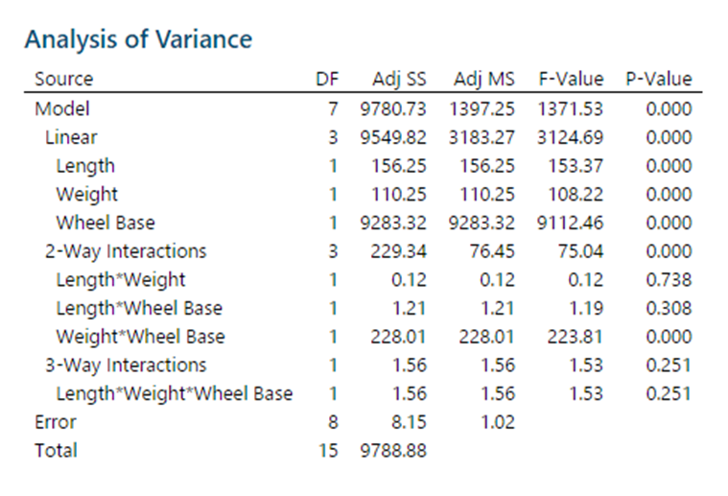

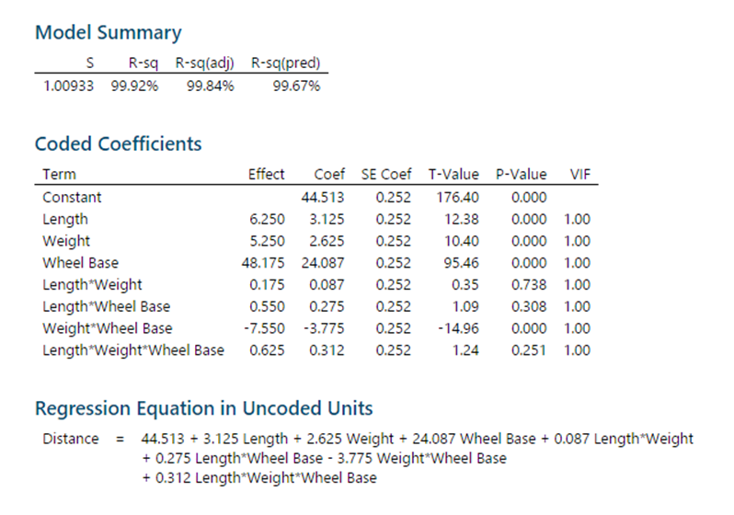

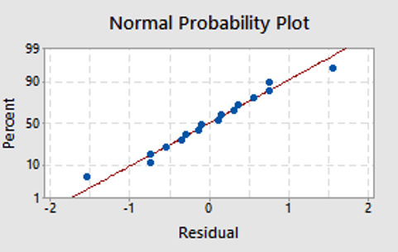

After creating ANOVA analysis in the minitab, we found that those three factors that we chose are all significant because their P-Values are below the significant level. And for the 2-Way interactions, only Weight*Wheel Base is significant. And our R-sq is similar to predicted R-sq, so that we could assume there is no overfitting in our model. And for the coefficients, wheel base has the highest main effect, and weight*wheel base has a negative main effect.

And from Normal Probability Plot, we could see the residuals are almost set on the line, which means that the residuals are normal distributed so model assumptions are not violated.

Some Graphs to further validate our claim.

1. NORMAL PLOT

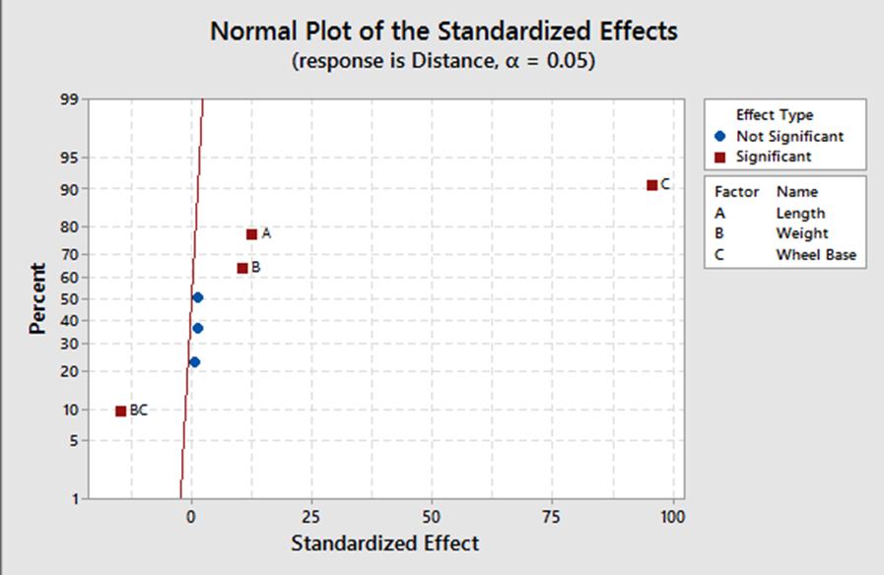

From Normal Plot of the Standardized Effects, we got the same result from the ANOVA analysis, Length, Weight, Wheel Base and Weight*Wheel Base are significant, and others are not.

2) PARETO CHART

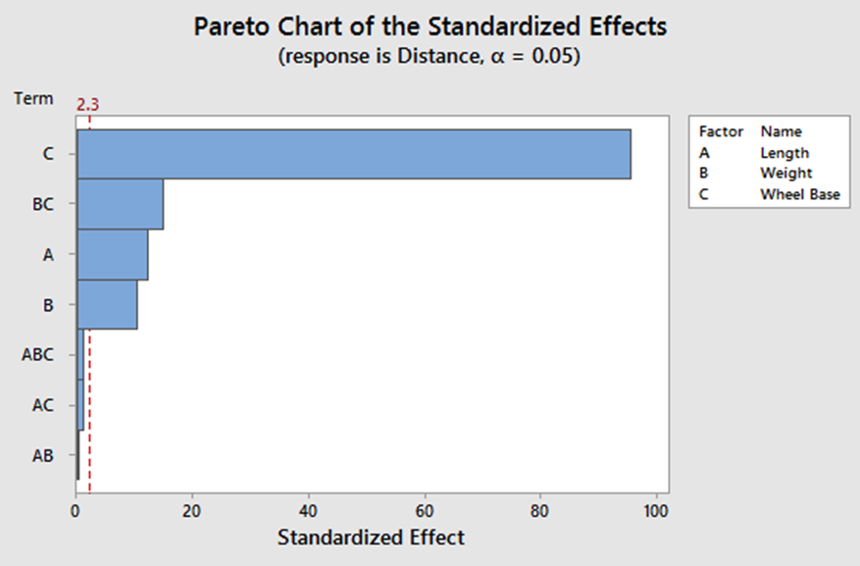

From Pareto Chart, we found that Factor C – Wheel Base has highest main effect, followed by Weight*Wheel Base, Length and Weight.

1. RESIDUAL PLOTS

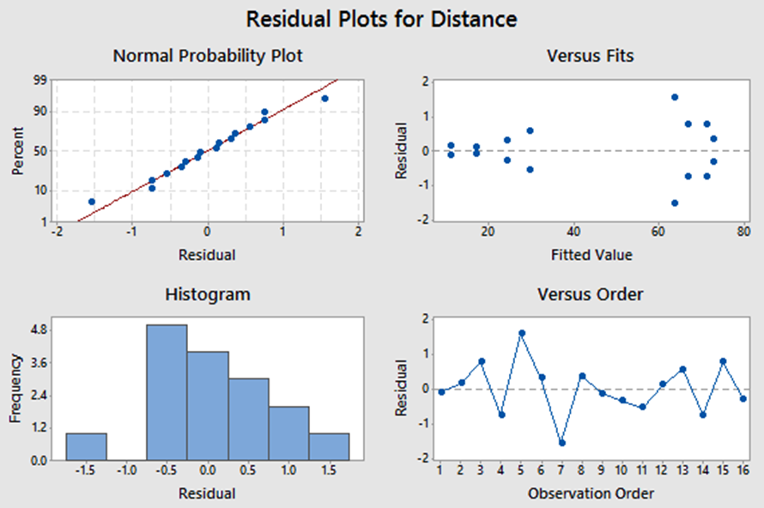

From Residual Plots, we could see that the residuals are normal distributed, and from the graph of Versus Fits, even though the plots are set opposite to the center line equally, we could not say that the residuals have equal variances, there might be some factors influencing the result and we need to investigate. Equal variance plots need more fanning.

1. MAIN EFFECTS

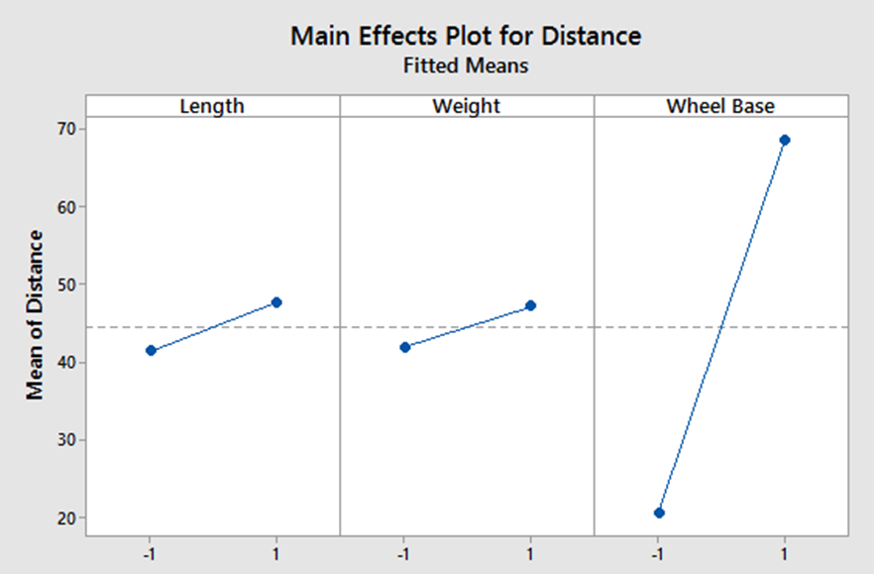

From the Main Effects Plot, we saw that these three factors all have positive main effects and Wheel Base has a highest main effect among these three factors.

1. INTERACTION PLOTS

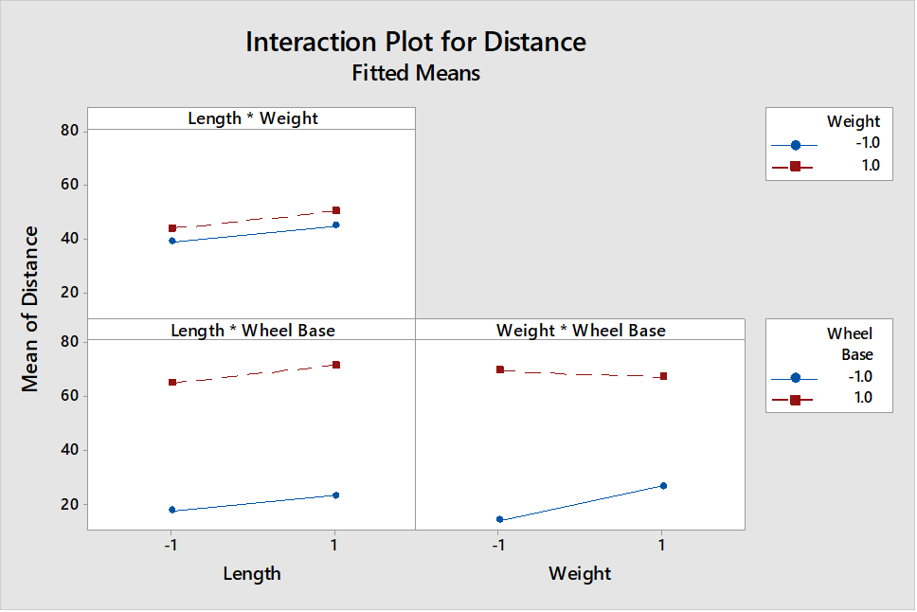

From Interaction Plot, because only Weight*Wheel Base is significant, so we only analyzed this part of chart. And we could see that when Wheel Base is high (Big wheel), the distance is longer, but with the increase of weight, the distance decreased.

**FINANCIAL ANALYSIS**

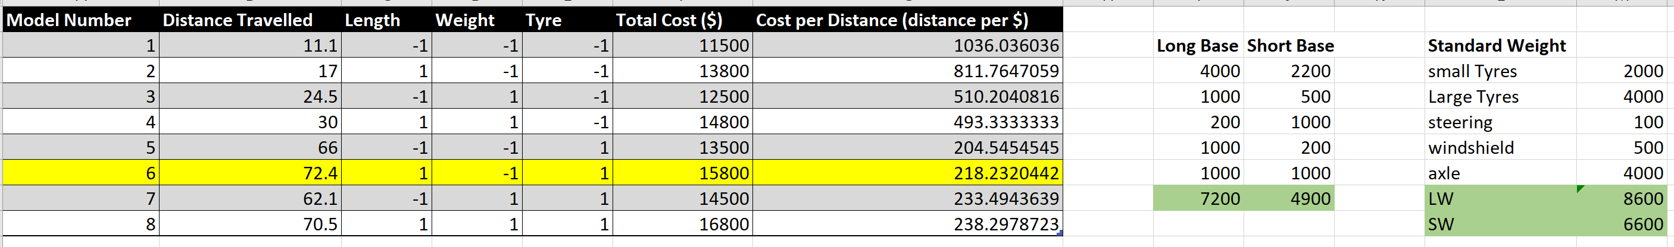

We calculated the total cost for each combination according to the different price for each part of car, and then divided the total cost by distance and got the cost per distance. We could see that for the longest distance (72.4), the cost per distance is low compared to other long distances, which means that the cost efficiency is good. However, compared to the total costs, in general, a shorter distance normally has a lower cost, so if we want to minimize the total cost, we might need to give up the longest distance, so there are trade-offs.

**CONCLUSIONS AND RECOMMENDATIONS**

Finally, we chose Length as High, Weight as Low and a Larger Wheel base as our best model for more distance, since all main effects, interaction plots were pointing towards the same. Equal Variance was an issue with our experiment and might need correction for a better analysis and Height could also be added as a contributing factor keeping in mind how it may cause other factors to react.

Cost analysis gave us better insights on how distance per part can be optimized keeping other factors constant. This experiment showed how quality management plays a major role in production and manufacturing and that certain tradeoffs need to be made in order to produce a better design.